Video to JPG

Overview:

This simple example…

- uses an iphone app: DashCam by JanBroek
- to capture geo referenced video into a .mov file.
- it then uses exifTool and ffmpeg to split the video into n jpgs. (see included mov_to_oid.ps1 power shell script)
- the jpgs and the embedded geo referenced info is used to create an input csv that can be used to create an Oriented Imagery Dataset (OID).
- The OID can then be published as a web layer.
- Next add the web layer to a web map and add the web map into an arcgis.com based experiencebuilder web app.
- Also add the Oriented Imagery Viewer and you will now be able to view the collected images.

Prerequisites:

- Install DashCam on your iphone
- Install exifTool (see included zip)
- Install ffmpeg (see included zip)

Example Experience Builder Oriented Imagery Viewer web app:

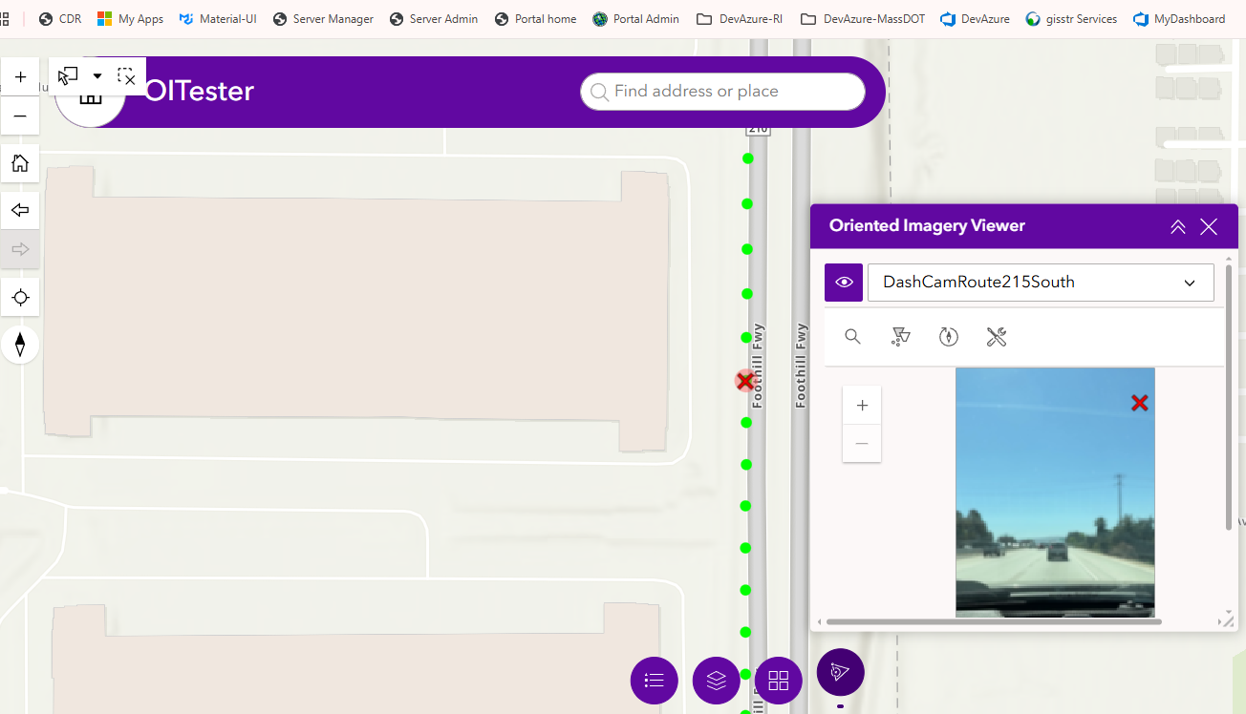

Processing:

CSV example content

X,Y,SRS,ImagePath,CameraHeading,CameraPitch,CameraRoll,CameraHeight,FarDistance,AcquisitionDate,SequenceOrder
-117.200398,34.097369,4326,"https://transdemo3.esri.com/oitester/frame_000001.jpg",185.1,2,0,1.5,30,2025-03-26T19:25:08,1
-117.200424,34.097128,4326,"https://transdemo3.esri.com/oitester/frame_000002.jpg",185,2.3,0,1.5,30,2025-03-26T19:25:09,2
-117.200449,34.096885,4326,"https://transdemo3.esri.com/oitester/frame_000003.jpg",184.9,2.2,0,1.5,30,2025-03-26T19:25:10,3
-117.200472,34.096642,4326,"https://transdemo3.esri.com/oitester/frame_000004.jpg",184.6,2.2,0,1.5,30,2025-03-26T19:25:11,4
-117.200494,34.096401,4326,"https://transdemo3.esri.com/oitester/frame_000005.jpg",184.5,2,0,1.5,30,2025-03-26T19:25:12,5
-117.200516,34.096163,4326,"https://transdemo3.esri.com/oitester/frame_000006.jpg",184.2,2.4,0,1.5,30,2025-03-26T19:25:13,6
-117.200535,34.095927,4326,"https://transdemo3.esri.com/oitester/frame_000007.jpg",183.9,2.6,0,1.5,30,2025-03-26T19:25:14,7
-117.200557,34.095689,4326,"https://transdemo3.esri.com/oitester/frame_000008.jpg",184.1,3,0,1.5,30,2025-03-26T19:25:15,8
-117.200578,34.095451,4326,"https://transdemo3.esri.com/oitester/frame_000009.jpg",184.1,2.2,0,1.5,30,2025-03-26T19:25:16,9
-117.200598,34.095208,4326,"https://transdemo3.esri.com/oitester/frame_000010.jpg",183.8,2.3,0,1.5,30,2025-03-26T19:25:17,10
-117.200617,34.094965,4326,"https://transdemo3.esri.com/oitester/frame_000011.jpg",183.6,2.4,0,1.5,30,2025-03-26T19:25:18,11
-117.200636,34.094721,4326,"https://transdemo3.esri.com/oitester/frame_000012.jpg",183.6,2.3,0,1.5,30,2025-03-26T19:25:19,12
-117.200653,34.094471,4326,"https://transdemo3.esri.com/oitester/frame_000013.jpg",183.1,2.3,0,1.5,30,2025-03-26T19:25:20,13
-117.200669,34.094227,4326,"https://transdemo3.esri.com/oitester/frame_000014.jpg",183,2.2,0,1.5,30,2025-03-26T19:25:21,14
-117.200685,34.093982,4326,"https://transdemo3.esri.com/oitester/frame_000015.jpg",183,2.4,0,1.5,30,2025-03-26T19:25:22,15

Script samples:

See included script: mov_to_oid.ps1

